**Experiment name:**

Study of Switching Characteristics

**Objectives:**

Study of the Switching characteristics of MOSFET.

**Apparatus:**

* 1x MOSFET (IRF540)
* Resistor - 1kΩ
* Trainer Board
* DC Power Supply
* Digital Multimeter
* Chords and wire

**Theory:** The two most common types of transistors are BJTs (Bipolar Junction Transistors) and MOSFETs (Metal Oxide Semiconductor Field Effect Transistors). There are two key differences between BJTs and FETs. While BJTs are current or voltage-controlled devices, FETs are charge-controlled. Moreover, FETs have very high input impedance, whereas BJTs have relatively low input impedance. Within FETs, there are two types: JFETs (Junction Field Effect Transistors) and MOSFETs. MOSFETs are preferred over JFETs in ICs because of their lower power dissipation. Modern electronics rely on CMOS (Complementary Metal Oxide Semiconductor) technology, which combines n-type and p-type MOSFETs. CMOS circuits consume very little power, enabling the integration of millions of transistors on a single chip. This experiment focuses on MOSFETs, specifically their switching behavior.

MOSFETs belong to the family of Insulated Gate Field Effect Transistors (IGFETs). The gate is insulated from the channel by an insulator, typically silicon dioxide (SiO₂), which gives MOSFETs their name. MOSFETs have three main terminals: Gate (G), Source (S), and Drain (D). Some MOSFETs also have a fourth terminal called the body or bulk. In NMOS devices, the body is held at the most negative voltage in the circuit, while in PMOS devices, it is held at the most positive voltage.

MOSFETs are classified into four types based on the channel type and how it is controlled:

1. Enhancement n-type MOSFET.
2. Enhancement p-type MOSFET.
3. Depletion n-type MOSFET.
4. Depletion p-type MOSFET.

The operation of a MOSFET depends on the gate voltage VGS. Applying a positive VGS (for n-type MOSFETs) repels holes from the channel region and attracts electrons, forming an n-channel that allows current to flow between the drain and source. When the concentration of electrons exceeds that of holes in the channel region, current can flow. This channel is extremely thin, but it is sufficient to carry the current.

For an NMOS transistor, when the VGS is low, the transistor is off, and the output voltage Vout remains high. When the VGS is high, the transistor is on, and Vout drops as current flows through the circuit. For PMOS transistors, a negative VGS is required to turn them on. The operation is similar to NMOS but with opposite voltage polarity. When used in a circuit, an NMOS transistor with VGS = 0 conducts almost no current, making Vout equal to VDD (the supply voltage). When VGS is raised to 5V, the MOSFET transitions along its load line, acting as a switch or inverter.

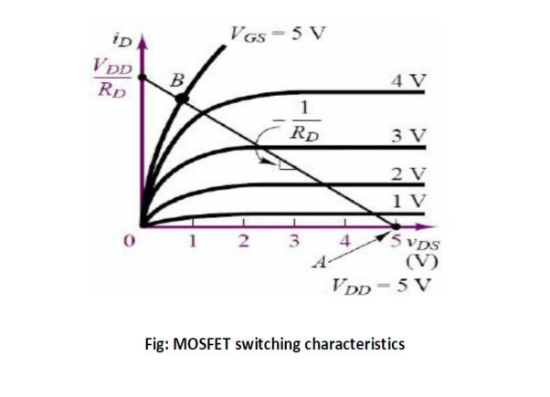

**Circuit Diagram:**

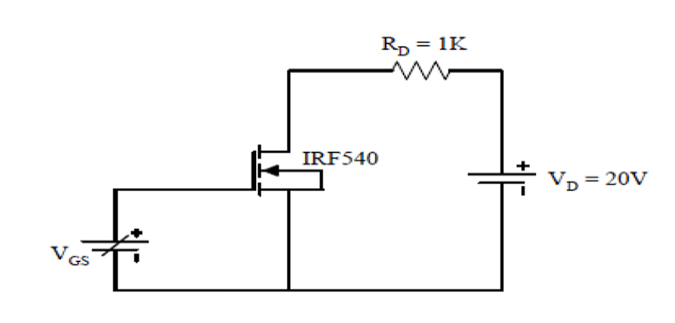

**Experimental Procedure:**

1. First we set the gate-source voltage (VGS) to zero, and the corresponding values of drain-source voltage (VDS), load voltage (VL), and drain current (ID) were recorded.
2. Then gate-source voltage (VGS) was gradually increased in small increments. For each increment, the values of VDS, VL, and ID were measured and recorded.
3. The process was continued until the drain current (ID) reached 20 mA or the MOSFET reached its saturation current.
4. The conditions of VDS and ID were noted at VGS=0 and when ID reached saturation.
5. We repeat the experiment with a supply voltage (VDD) set to 15 V.

**Experimental Data Table:**

**Results:** The experiment showed how an NMOS transistor switches on and off based on the gate-source voltage VGS. When VGS was 0, the transistor was off. The drain-source voltage VDS was almost equal to the supply voltage VDD, the load voltage VL was nearly zero, and the drain current ID was also 0. As VGS increased past the threshold voltage, the transistor started to turn on. VDS dropped, VL increased, and ID increased significantly. When VGS was high enough, the transistor reached saturation, where ID stayed steady at 20 mA, VL reached its peak, and VDS was very low. Using a higher supply voltage (VDD=15 volts) gave similar results but with slightly higher values. This confirmed that the NMOS transistor works as a switch, turning on and off depending on VGS.

**Discussion:**

Through this experiment, we gained an understanding of the functions of MOSFETs, which can be used for both amplification and switching, depending on their characteristics. Based on the MOSFET characteristic curve, we observed that the gate-to-source voltage (VGS) must be positive for current conduction. When VGS exceeds the threshold voltage (determined by the designer) and the drain-to-source voltage (VDS) is greater than VGS minus the threshold voltage (VGS - VT), the MOSFET operates in the saturation region, making it suitable for amplification. Conversely, when VDS is less than VGS - VT, the MOSFET enters the triode region and functions as a switch. Additionally, when VGS is zero, the MOSFET is in the cutoff region and is commonly used as a switch in digital electronics.

**Simulation:**

